**Java provides four data types for number related task**

byte -> short -> int -> Long

here byte is the smallest and long is the longest

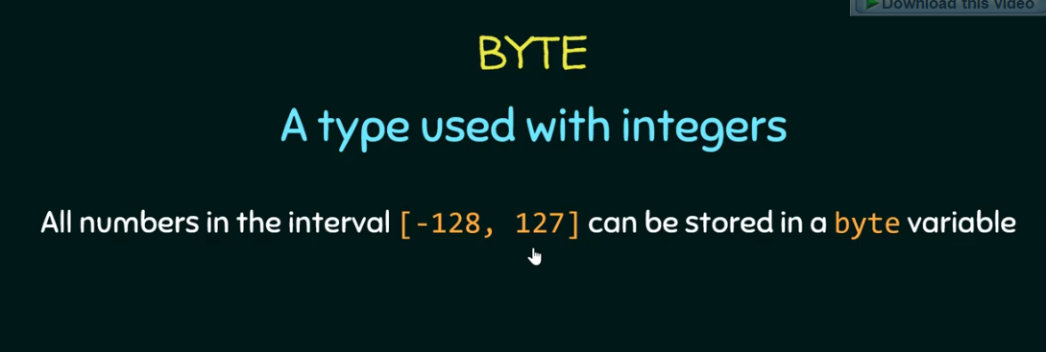

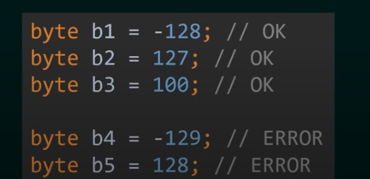

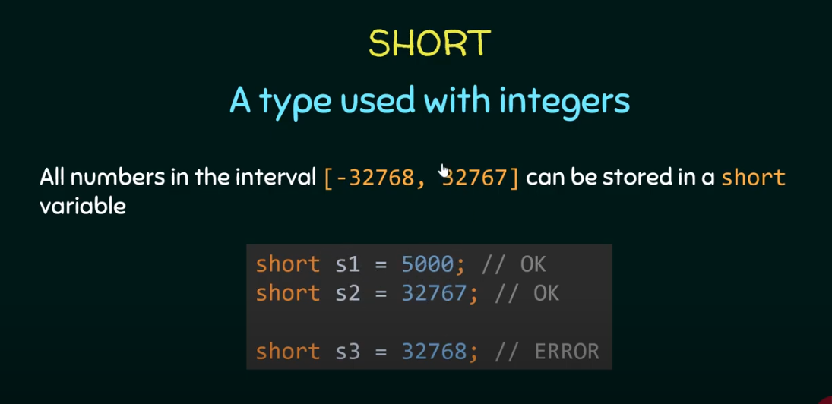

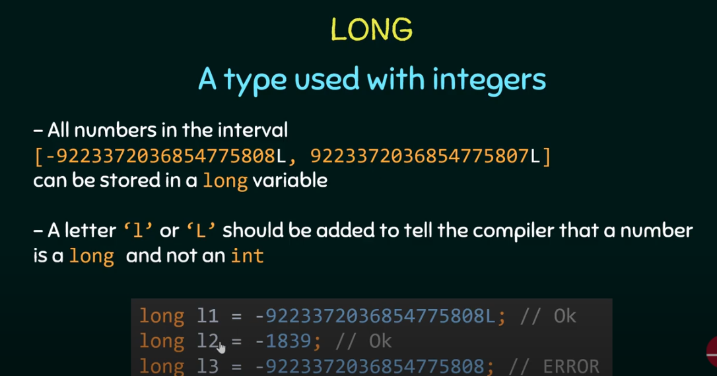

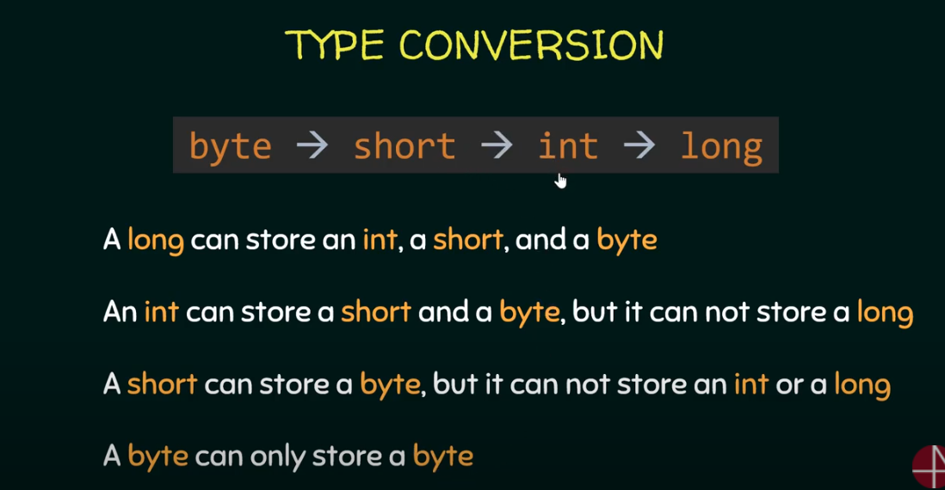

**Automatic type conversion for char data types**

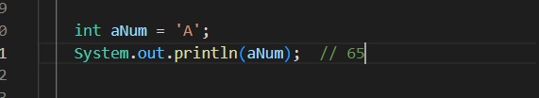

doing this in java, java will store the ASCI value of the char in to the variable

**Type promotion rules in Java**

In an expression if there are byte type, short type and char type, int type then the whole expression will be converted in to the int type

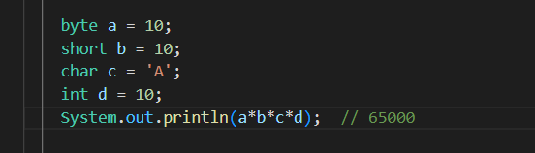

if there are byte type, short type and char type, int type and float type then the whole expression will be converted in to the float type

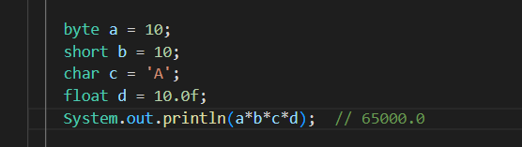

if there is one long type then the whole result will be in long type

the thing is the result will be converted to the longest type

**byte -> short -> int -> Long**

**here byte is the smallest and long is the longest**